**DAILY ONLINE ACTIVITIES SUMMARY**

|  |  |  |  |  |  |  |  |
| --- | --- | --- | --- | --- | --- | --- | --- |
| **Date:** | **11/06/2020** | | | | **Name:** | **Imran Khan** | |
| **Sem & Sec** | **8th A** | | | | **USN:** | **4AL16CS040** | |
| **Online Test Summary** | | | | | | | |
| **Subject** | | **SMS** | | | | | |
| **Max. Marks** | | **60** | | **Score** | | **60** | |
| **Certification Course Summary** | | | | | | | |
| **Course** | **AMAZON training** | | | | | | |
| **Certificate Provider** | | | **AWS** | **Duration** | | | **3 HOURS** |
| **Coding Challenges** | | | | | | | |
| Problem Statement:  Write a C Program to remove the duplicate elements.. | | | | | | | |
| **Status: Solved** | | | | | | | |
| **Uploaded the report in Github** | | | | **yes** | | | |
| **If yes Repository name** | | | | **Imran040** | | | |
| **Uploaded the report in slack** | | | | **yes** | | | |

Online test details:

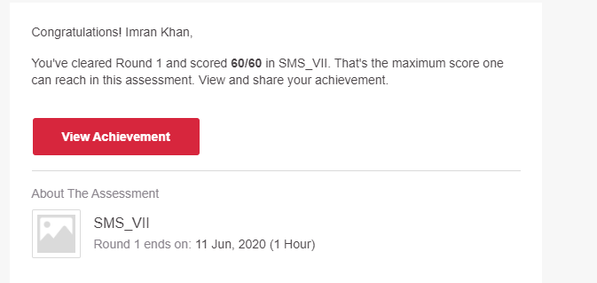

**Certification Course Details**:

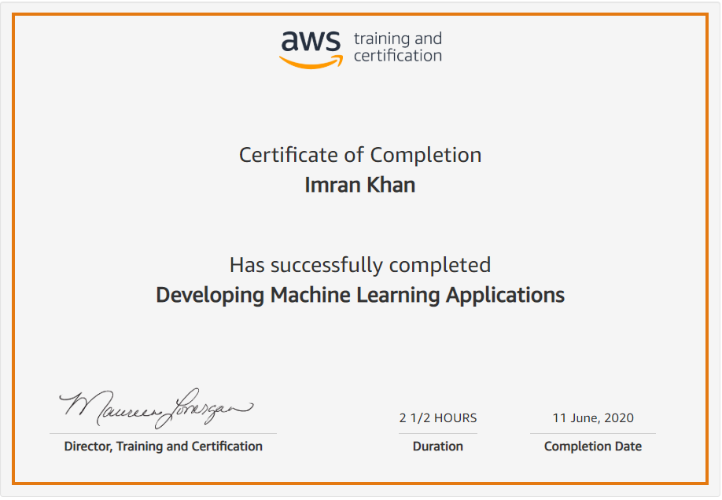

**Coding Challenges Details**:

**program1:**

|  |  |  |  |
| --- | --- | --- | --- |
|  | | | |
|  | |
| #include<stdio.h> | |
|  | |  |
|  | | int remove_duplicate_elements(int arr[], int n) |
|  | | { |
|  | |  |
|  | | if (n==0 || n==1) |
|  | | return n; |
|  | |  |
|  | | int temp[n]; |
|  | |  |
|  | | int j = 0; |
|  | | int i; |
|  | | for (i=0; i<n-1; i++) |
|  | | if (arr[i] != arr[i+1]) |
|  | | temp[j++] = arr[i]; |
|  | | temp[j++] = arr[n-1]; |
|  | |  |
|  | | for (i=0; i<j; i++) |
|  | | arr[i] = temp[i]; |
|  | |  |
|  | | return j; |
|  | | } |
|  | |  |
|  | |  |
|  | | int main() |
|  | | { |
|  | | int n; |
|  | | scanf("%d",&n); |
|  | | int arr[n]; |
|  | | int i; |
|  | | for(i = 0; i < n; i++) |
|  | | { |
|  | | scanf("%d",&arr[i]); |
|  | | } |
|  | |  |
|  | | n = remove_duplicate_elements(arr, n); |
|  | |  |
|  | |  |
|  | | for (i=0; i<n; i++) |
|  | | printf("%d ",arr[i]); |
|  | |  |
|  | | return 0; |
|  | | } |